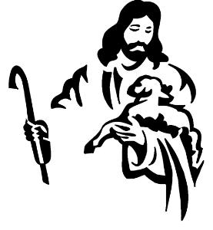
Catechesis of the Good Shepherd Calendar
2022-2023
CGS sessions are held at Prince of Peace on:
Monday 10:00-Noon (Level1,2) and 4:30-6:00 pm (Levels 1, 2,3)
Wednesday 6:00-7:30 pm (Levels 1, 2 & 3)
Our CGS calendar provides the dates when youth will meet throughout the year.
Please check Wood TV 8, WZZM 13 and Fox 17 for cancellations due to inclement weather.
Sign up for My Parish App
~~~~~~~~~~~~~~~~~~~~~~~~~~~~~~~~~~~~~~~~~~~~~~~~~~~~~~~~~~~~~~~~~~~~~~~~~~
September 25 Parish Fall Festival, Games and Lunch provided after 10:30am Mass, tour the Atriums
October 2 Open house after 10:30am Mass, come tour the Atriums & be part of a special blessing!
October 3 & 5 CGS meets
October 10 & 12 CGS meets
October 17 & 19 CGS meets
October 24 & 26 CGS meets
October 31 NO CGS
November 2 CGS meets
~~~~~~~~~~~~~~~~~~~~~~~~~~~~~~~~~~~~~~~~~~~~~~~~~~~~~~~~~~~~~~~~~~~~~~~~
November 7 & 9 CGS meets
November 14 & 16 CGS meets
November 21 & 23 No CGS -Thanksgiving Break
November 28 & 30 CGS meets
~~~~~~~~~~~~~~~~~~~~~~~~~~~~~~~~~~~~~~~~~~~~~~~~~~~~~~~~~~~~~~~~~~~~~~~~~~
December 5 & 7 CGS meets
December 11 Nativity Story Character pictures after 10:30am mass for the Christmas Nativity
December 12 & 14 CGS meets
December 19 & 21 CGS meets
December 26 & 28 No CGS - Christmas Break
~~~~~~~~~~~~~~~~~~~~~~~~~~~~~~~~~~~~~~~~~~~~~~~~~~~~~~~~~~~~~~~~~~~~~~~~~~
January 2 & 4 No CGS - New Year’s Break
January 9 & 11 CGS meets
January 16 & 18 CGS meets
January 23 & 25 CGS meets
January 29 Sacrament Parent Meeting / 11:30-12:30 pm / Ed Wing LEVEL 2 ATRIUM
January 30 & Feb 1 CGS meets

Catechesis of the Good Shepherd Calendar
2022-2023
CGS sessions are held at Prince of Peace on:
Monday 10:00-Noon (Level 1,2) and 4:30-6:00 pm (Levels 1, 2 & 3);
Wednesday 6:00-7:30 pm (Levels 1, 2 & 3).

~~~~~~~~~~~~~~~~~~~~~~~~~~~~~~~~~~~~~~~~~~~~~~~~~~~~~~~~~~~~~~~~~~~~~~~~~~

February 6 & 8 CGS meets
February 13 & 15 CGS meets
February 20 & 22 No CGS, Lent begins February 22, Ash Wednesday Mass at 7pm
February 27, March 1 CGS Meets
~~~~~~~~~~~~~~~~~~~~~~~~~~~~~~~~~~~~~~~~~~~~~~~~~~~~~~~~~~~~~~~~~~~~~~~~~~
March 6 & 8 CGS meets
March 13 & 15 CGS meets
March 18 First Reconciliation Retreat 9:30am-Noon
March 20 & 22 CGS meets
March 27 & 29 CGS meets
~~~~~~~~~~~~~~~~~~~~~~~~~~~~~~~~~~~~~~~~~~~~~~~~~~~~~~~~~~~~~~~~~~~~~~~~~~
April 3 & 5 No CGS – Spring Break
April 10 & 12 CGS meets
April 17 & 19 CGS meets
April 22 First Holy Communion Retreat 9:30am-Noon
April 24 & 26 CGS meets
April 27 First Reconciliation Prayer Service 6:30pm-7:30pm
April 30 First Holy Communion Mass 10:30am
~~~~~~~~~~~~~~~~~~~~~~~~~~~~~~~~~~~~~~~~~~~~~~~~~~~~~~~~~~~~~~~~~~~~~~~~~~
May 1 & 3 CGS meets
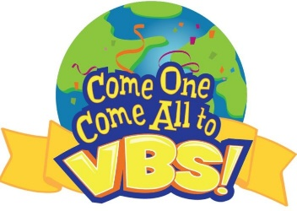
~~~~~~~~~~~~~~~~~~~~~~~~~~~~~~~~~~~~~~~~~~~~~~~~~~~~~~~~~~~~~~~~~~~~~~~~~~
VBS July 10-13, 2023
Contact Holly Champoux
Phone: 231-744-3321 ext 128
Email: hchampoux@princeofpeacenm.org

