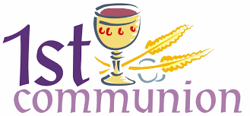
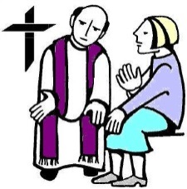
Sacramental Event Calendar

2022

March 19th In-person Parent & Child Reconciliation Retreat 2pm-6pm
Retreat concludes after 5pm mass

April 23rd In-person Parent & Child Eucharist Retreat 2pm-6pm
Retreat concludes after 5pm mass

April 28th First Reconciliation Prayer Service/Church and Hall 6:30-7:30pm

April 30th Option One: 1st Eucharist Celebrated 5pm Mass arrive at 4:15pm
May 1st Option Two: 1st Eucharist Celebrated 10:30am Mass arrive at 9:45am

- All sacramental events will take place at Prince of Peace Parish

- One parent, along with their child, must attend all sacramental events

- Parent and child must complete Together in Jesus First Reconciliation and First Eucharist packets

- All parents must turn in a completed Sacramental Candidate Registration form

- Parents are required to provide a certified baptismal certificate, if your child was not baptized at Prince of Peace or St. Mary of the Woods Chapel.
We can make a copy of your child’s original Baptismal Certificate.
Otherwise, you will need to contact the parish office, where your child’s baptism took place, and request a copy be faxed to Prince of Peace Parish at
231 744-4859 or emailed at hchampoux@princeofpeacenm.org

Contact Information: Holly Champoux
Email: hchampoux@princeofpeacenm.org
Phone: 231 744-3321 x128

