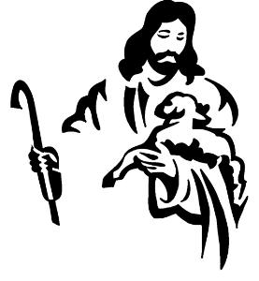
Catechesis of the Good Shepherd Calendar
2021-2022
CGS sessions are held at Prince of Peace on:
Monday 10:00-11:30 am (Level 1) and 4:30-6:00 pm (Levels 1, 2);
Wednesday 6:00-7:30 pm (Levels 1, 2 & 3).
Our CGS calendar provides the dates when youth will meet throughout the year.

Please check Wood TV 8, WZZM 13 and Fox 17 for cancellations due to inclement weather.
Sign up for Remind text alerts rmd.at/cgs-pop or text the message @cgs-pop to the number 81010 to sign up for Remind text alerts.
~~~~~~~~~~~~~~~~~~~~~~~~~~~~~~~~~~~~~~~~~~~~~~~~~~~~~~~~~~~~~~~~~~~~~~~~~~
October 11 & 13 CGS meets Ordinary Time
October 18 & 20 CGS meets
October 25 & 27 CGS meets
~~~~~~~~~~~~~~~~~~~~~~~~~~~~~~~~~~~~~~~~~~~~~~~~~~~~~~~~~~~~~~~~~~~~~~~~
November 1 & 3 CGS meets
November 8 & 10 CGS meets
November 15 & 17 CGS meets
November 22 & 24 No CGS -Thanksgiving Break
~~~~~~~~~~~~~~~~~~~~~~~~~~~~~~~~~~~~~~~~~~~~~~~~~~~~~~~~~~~~~~~~~~~~~~~~~~
November 29, Dec. 1 CGS meets - Advent Season
December 6 CGS meets
December 8 No CGS—Holy Day of obligation Mass 7pm
December 13 & 15 CGS meets
December 20 & 23 No CGS - Christmas Break
December 27 & 29 No CGS - New Year’s Break
~~~~~~~~~~~~~~~~~~~~~~~~~~~~~~~~~~~~~~~~~~~~~~~~~~~~~~~~~~~~~~~~~~~~~~~~~~
January 3 & 5 CGS meets
January 10 & 12 CGS meets - Ordinary Time
January 17 & 19 CGS meets
January 24 & 26 CGS meets
January 30 Sacrament Parent Meeting / 11:30-12:30 pm / Ed Wing LEVEL 2 ATRIUM
January 31 & Feb 2 CGS meets ~~~~~~~~~~~~~~~~~~~~~~~~~~~~~~~~~~~~~~~~~~~~~~~~~~~~~~~~~~~~~~~~~~~~~~~~~~
February 7 & 9 CGS meets
February 14 & 16 CGS meets

Catechesis of the Good Shepherd Calendar
2021-2022
CGS sessions are held at Prince of Peace on:
Monday 10:00-11:30 am (Level 1) and 4:30-6:00 pm (Levels 1, 2 & 3);
Wednesday 6:00-7:30 pm (Levels 1, 2 & 3).

~~~~~~~~~~~~~~~~~~~~~~~~~~~~~~~~~~~~~~~~~~~~~~~~~~~~~~~~~~~~~~~~~~~~~~~~~~

February 21 No CGS
February 23 CGS meets
February 28 CGS meets
March 2 No CGS – Lent begins March 2, Ash Wednesday Mass at 7pm
~~~~~~~~~~~~~~~~~~~~~~~~~~~~~~~~~~~~~~~~~~~~~~~~~~~~~~~~~~~~~~~~~~~~~~~~~~
March 7 & 9 CGS meets – Lent
March 14 & 16 CGS meets
March 21 & 23 CGS meets
March 28 & 30 CGS meets
~~~~~~~~~~~~~~~~~~~~~~~~~~~~~~~~~~~~~~~~~~~~~~~~~~~~~~~~~~~~~~~~~~~~~~~~~~
April 4 & 6 No CGS – Spring Break
April 11 & 13 CGS meets – Holy Week
April 18 & 20 CGS meets
April 25 & 27 CGS meets
~~~~~~~~~~~~~~~~~~~~~~~~~~~~~~~~~~~~~~~~~~~~~~~~~~~~~~~~~~~~~~~~~~~~~~~~~~
May 2 & 4 CGS meets
May 9 & 11 CGS meets – Pentecost Meditation
May 16 & 18 CGS meets – Pentecost Celebration, program ends
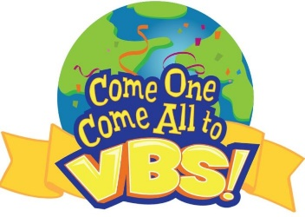
~~~~~~~~~~~~~~~~~~~~~~~~~~~~~~~~~~~~~~~~~~~~~~~~~~~~~~~~~~~~~~~~~~~~~~~~~~

VBS Summer 2022, dates will be forthcoming!
Contact Holly Champoux
Phone: 231-744-3321 ext 128
Email: hchampoux@princeofpeacenm.org

